CSCS 351: Software Quality Assurance

Assignment 2

Name: Muhammad Muzammil

Roll Number: 231485432

Section: A

Teacher: Saad Bin Saleem

**API TESTING:**

The two snapshots attached are the code and the result of the testing.

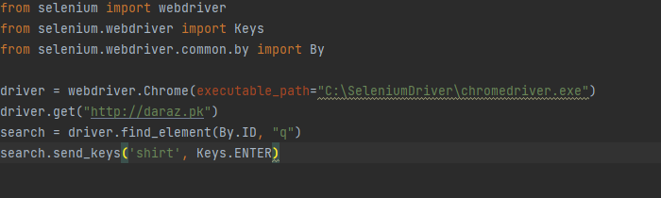

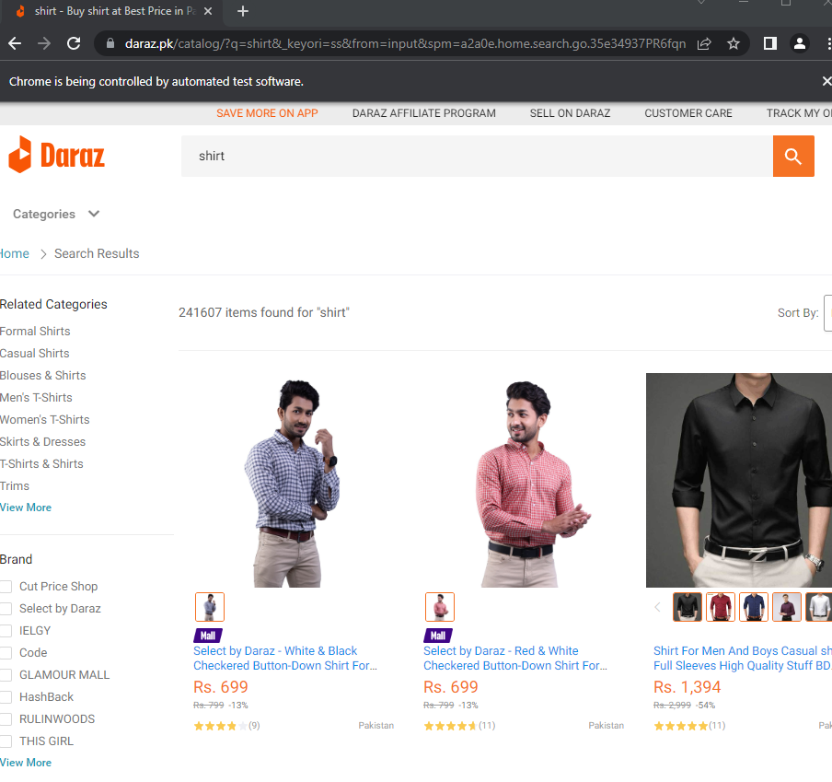

Code:

from selenium import webdriver  
from selenium.webdriver import Keys  
from selenium.webdriver.common.by import By  
  
driver = webdriver.Chrome(executable_path="C:\SeleniumDriver\chromedriver.exe")  
driver.get("http://daraz.pk")  
search = driver.find_element(By.ID, "q")  
search.send_keys('shirt', Keys.ENTER)